Quick Links
  - James Fallows
  - Ta Nehisi Coates
  - Manage subscription
Politics

The Inconvenience of Being a Woman Veteran
When leaving the service, women are often faced with a slew of challenges as they try to assimilate into civilian life.
Sarah Maples
Nov 22, 2017
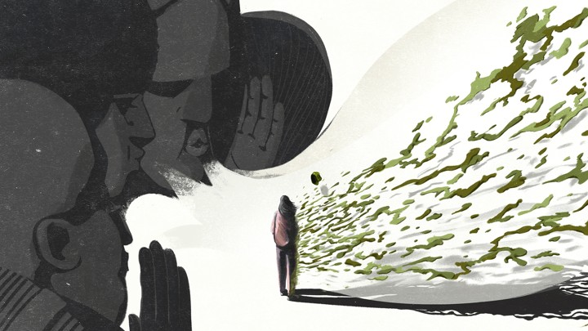Jacob Myrick
This is the fifth installment in our series of essays written by veterans. We asked service members to share how their time in uniform shaped their perspectives on American life.
I happen to be a woman. This is often inconvenient. It was inconvenient for the military and, now that I’m out of the military, it’s still inconvenient. In multiple surveys and anecdotes, both women who are serving and women who have served repeatedly list gender bias as an issue, though the way it manifests itself differs during and after their time in the military.
The military doesn’t just urge women, it requires them—especially if they want to succeed—to view themselves on the same playing field as their male counterparts. They are also expected to behave and perform in traditionally masculine ways—demonstrating strength, displaying confidence in their abilities, expecting to be judged on their merits and performance, and taking on levels of authority and responsibility that few women get to experience. The uniform and grooming standards work to downplay their physical female characteristics. Additionally, the expectation—explicit or implicit—is that they also downplay other attributes that are traditionally considered feminine, such as open displays of emotion. That’s not to say that gender isn’t going to be noticed or that others aren’t going to make it an issue—they will. But highlighting female characteristics is undesirable. As General Lori J. Robinson, the U.S. military’s first female combatant commander, put it: “I’m a general, a commander, an airman. And I happen to be a woman.”
When many women leave the service, they expect that being a woman in the civilian community will be easier, but that isn’t always the case. They have to prove their abilities all over again, earn their place at the table again. As veterans, they’re not afraid to prove themselves. They proved themselves in boot camp. They proved themselves at tech training. They proved themselves every time they arrived at a new duty station. They have plenty of practice proving themselves. They can prove themselves one more time. The difference, this time, is that the individuals on the other end are not prepared for them to do so.
There are roughly 2 million women veterans in the United States and Puerto Rico, according to the Department of Veterans Affairs. Without the uniform, there is no outward indication that these women are veterans. In a recent video, Kirstie Ennis, Marine door gunner, amputee, and first veteran—male or female—to grace the cover of ESPN Magazine’s Body Issue, stated that she is often told that she is “too pretty” or “too frail” for people to believe she was a Marine.
What civilians do not realize, what women veterans often do not even realize, is that they might appear to be like other women, but they aren’t operating on the expectations traditionally applied to women. Behaving at odds with these traditional expectations is often a significant drawback in the ability of women veterans to fit-in in the workplace, in the dating world, in the female civilian community, in society in general. And directly challenging these expectations can often lead to conflict.
On active duty, women were my support network, a situation encouraged both by our small numbers—approximately 15 percent of the active duty force is women—and by the military’s emphasis on teamwork. My experiences with civilian women, however, have not always been as friendly. Other women veterans have also reported negative experiences with civilian women, ranging from lack of understanding and inability to relate to cold shoulders.
In a 2015 study on how female veterans cope with transition, one participant said: “When I first got out of the military, I had a hard time with [women], civilian women. They didn’t understand why I looked so militant. ‘Why do you walk straight up? Why do you walk so?’” Operating in male-dominated environments and doing traditionally male activities, up to and including combat, are so different from the experiences of civilian women that the two sides often cannot relate. Moreover, the behaviors—male behaviors—that women veterans learned were correct in the military are now at odds with the expectations civilians have for women. Instead of helping them fit in, these same behaviors now make them stand out, often in ways that make other people uncomfortable.
Complicating matters is that, while I and other women veterans make efforts to assimilate, we are often reluctant to completely lose the identity we developed in the military, particularly if it means assuming traditional gender roles. The idea that the male standard is the normal one has become so ingrained during service that women veterans don’t realize they’ve absorbed the spoken or unspoken message that adding “female” to something diminishes it.
Military women often cite that they feel slighted in comparison to their male counterparts, that they don’t get the same promotion opportunities or the same recognition. This is not surprising—they are competing on standards that were designed and built by men to bring out the best in men. The fact that women are competing against those standards at all is hugely important. After leaving the service, they don’t realize that they often continue to view themselves under those same metrics. They expect, for example, to be afforded the same respect as their male counterparts—veteran and civilian.
And yet, women are often denied recognition for their military accomplishments. In a 2016 Service Women’s Action Network survey, 74 percent of the respondents said that the general public did not recognize their service.
Recently, I had dinner with several of my coworkers, all male veterans. We were joined by two civilian men, both friends of one of my coworkers. During the conversation, a veteran asked if I had ever slept in a CONEX, a large shipping container that doubles as housing for many deployed service members. I replied that I had not, but that I had worked in a CONEX when I was in Afghanistan. To which one of the civilian men responded, “Oh, are you a military brat?”
I was a military brat, for a short period of time when my mother was in the Army. That was not, however, why I was in Afghanistan—that was for my role as senior Taliban/Al Qaeda analyst for a three-star general. This kind of exchange, where a woman’s connection to the military is assumed to be earned by another, most likely male, individual can be insulting and disheartening to a woman who has served.
The perceived invalidation of a woman’s service can also feel as if her experiences during or related to her service, to include combat, service-connected disabilities, and sexual harassment/assault, are also invalidated. In the past, many women either didn’t take advantage of resources available to veterans or found that available resources didn’t take into account the unique needs of women veterans. Today, women veterans are still facing a number of challenges, including being three to four times as likely as their civilian women counterparts to become homeless and 2.5 times more likely to commit suicide.
The number of women veterans continues to grow—currently less than 10 percent of the veteran population, they are projected to make up 16 percent by 2043. The successes of women like Robinson, Ennis, Secretary of the Air Force Heather Wilson, Senators Tammy Duckworth and Joni Ernst, Representatives Tulsi Gabbard and Martha McSally, and others are helping to change the impressions people have of women who serve. And efforts by the Department of Veterans Affairs, veteran service organizations, and other groups focusing on addressing the needs of women veterans are slowly improving their transition experience. Efforts for gender equality within the civilian community are also making the lack of conformity to traditionally feminine roles more acceptable.
Still, there are likely more obstacles to overcome in the near future. The lifting of the combat exclusion policy in 2013, for example, has opened the door for female service members to make their way into the final male-only spaces remaining in the military. Recent developments have included the first female Army Ranger school graduates and the first successful Marine infantry officer candidate. With the debates for keeping women out of these areas largely focused on a perceived lowering of standards, it is likely that these women will be required to adopt even more thoroughly traditionally male characteristics in order to succeed in these news roles. Additionally, the inevitable future conflict in which women will be committed to ground combat in large scale numbers will result in an even larger divide in the experiences of military and civilian women.
This means that women, both during and after service, are likely to find being a woman inconvenient for some time to come.
We want to hear what you think about this article. Submit a letter to the editor or write to letters@theatlantic.com.
Sarah Maples is the director of National Security and Foreign Affairs at the Veterans of Foreign Wars. She previously served as an intelligence officer in the Air Force.

